MID Server in ServiceNow: -
The management, Instrumentation, and Discovery(MID) server is a lightweight Java application that runs as a Windows service or UNIX daemon on a server in your local network.
What ServiceNow application use a MID Server?

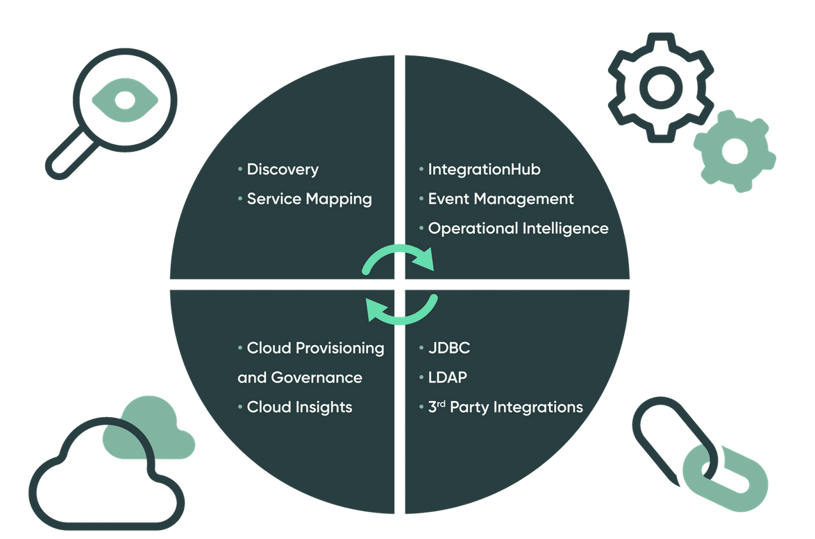

What does a MID Server do?
The MID Server facilitates communication and the movement of data between a ServiceNow instance and external applications, data sources, servers and services.
ServiceNow is normally hosted is a ServiceNow datacenter and it does not have the ability to access the enterprise’s network directly. Many enterprises have multiple networks, often separated by slow Wan links or security barriers. Often ServiceNow applications such as Discovery and Service Mapping need access to all of them.
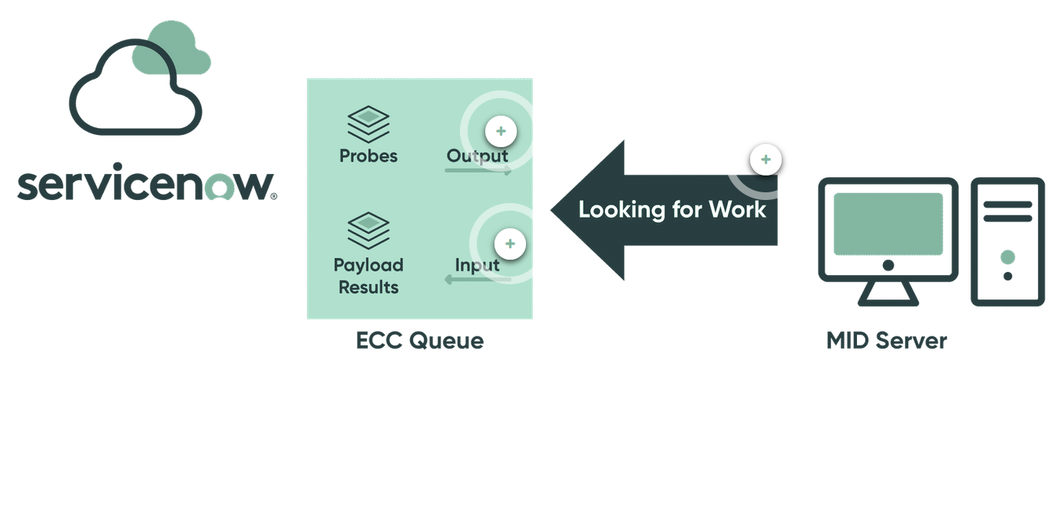

Where are MID server located?
MID Servers often reside behind the company firewall or within the demilitarized zone (DMZ) allowing for communication between ServiceNow and the rest of the company network.
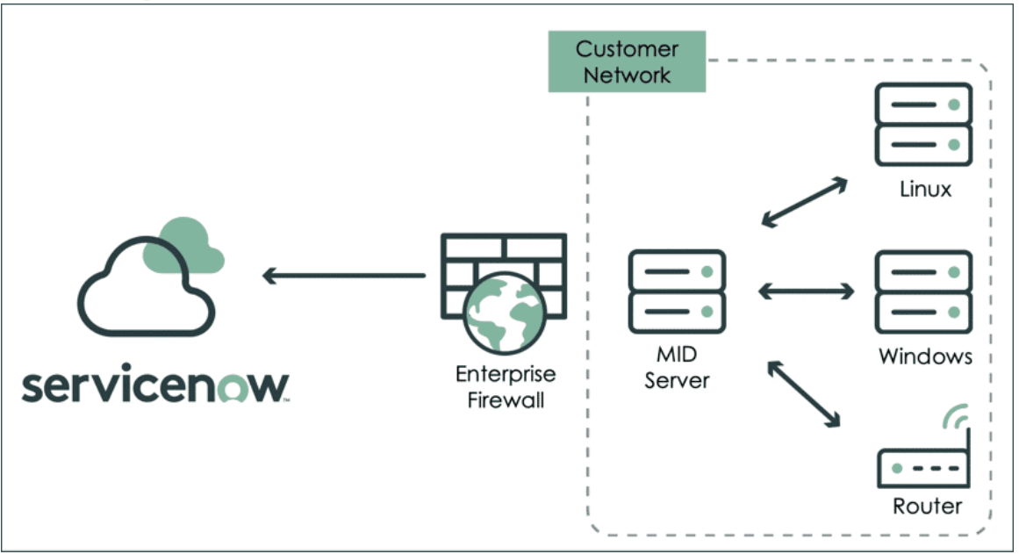

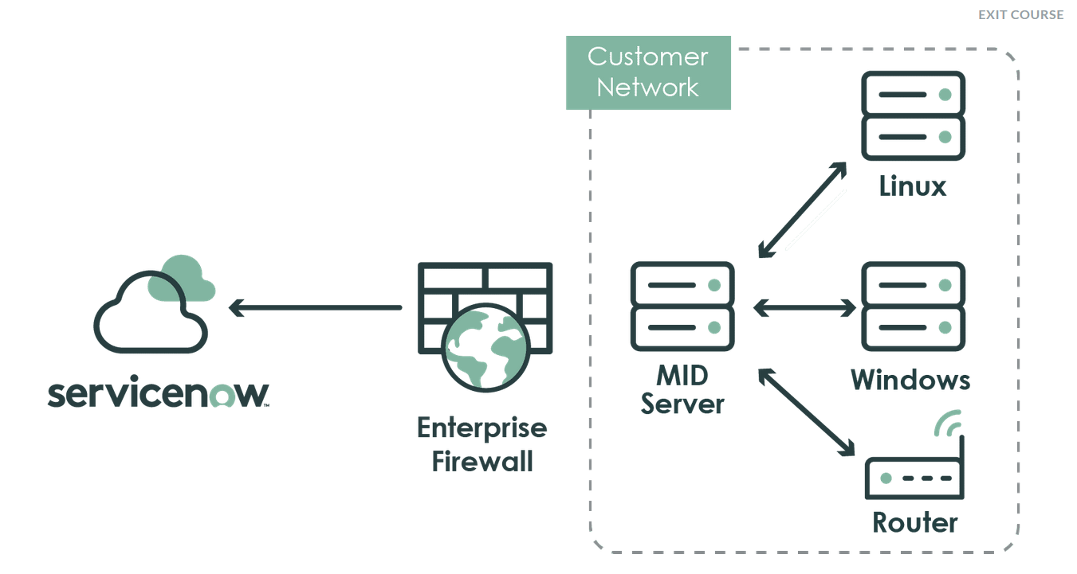

Installation of MID Server includes: -
- Create a MID Server User
- Download and install MID Server
- Validate MID Server
To install Navigate to Guided Setup > ITOM Guided Setup
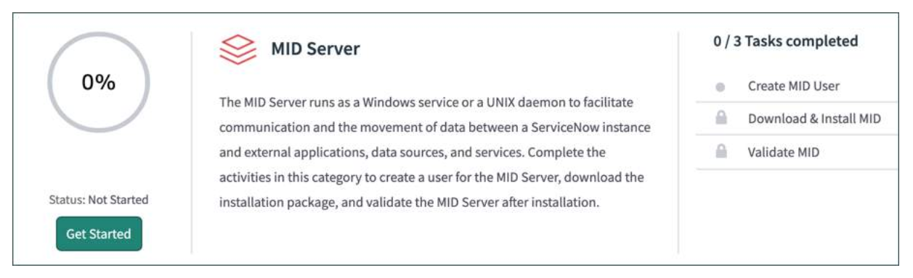
Created: -
User Name: - mymidserver
Password: - deep@1998

